School Subjects ['sʌbʤekts]
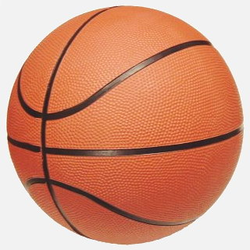  PE  [‘pi:' i:] | 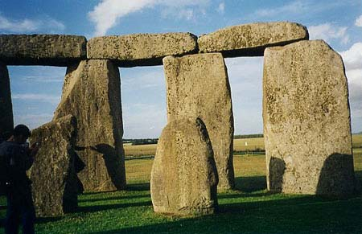  History  ['hɪstərɪ] | 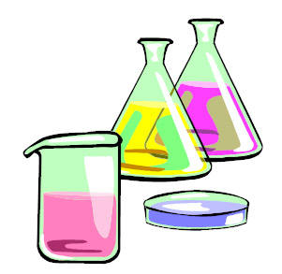  Science  ['saɪəns] | 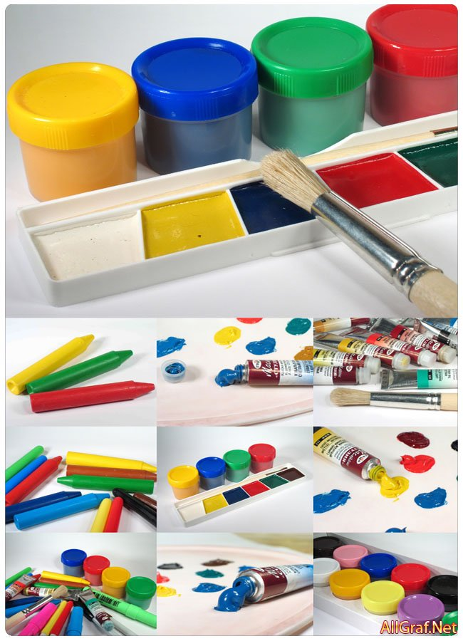  Art  [ɑːt]
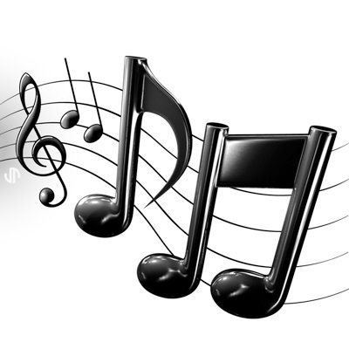  Music  ['mjuːzɪk] | 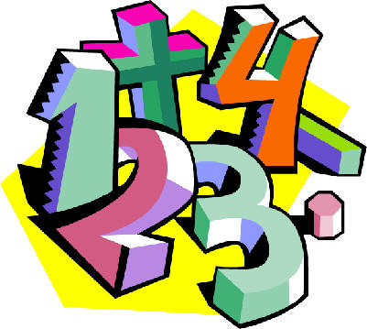  Maths  [mæθs] | 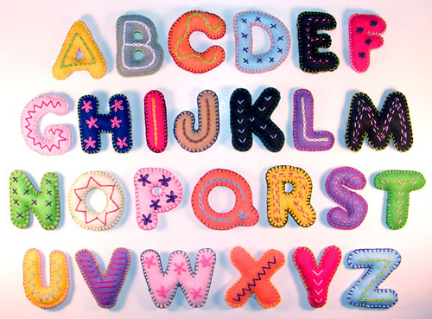  English  ['ɪŋglɪʃ] | 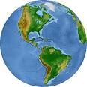  Geography  [ʤɪ'ɔgrəfɪ]

